NEXT STEPS PROGRAM
Team Excel is expanding their
Synchronized Skating program for the 2012/13 Season
Fielding Teams in 3 locations!
Beginner, Preliminary, Open Juvenile,
Juvenile, Intermediate, Senior & Collegiate
Foxboro-Boston-Marlborough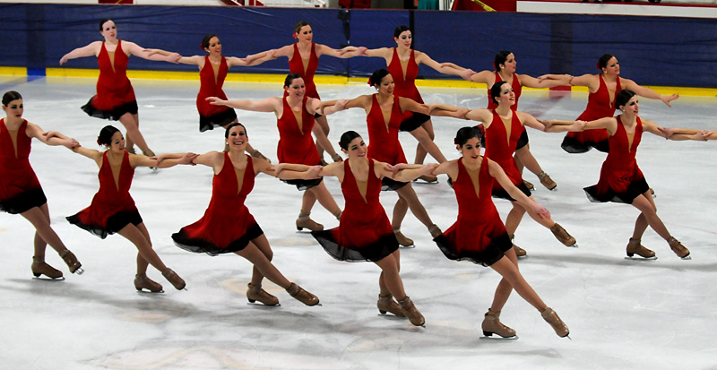
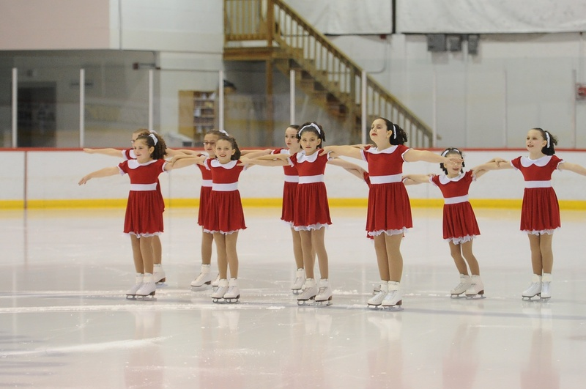

Team Excel
Synchronized Skating
NEXT STEPS
Skills & Drills Sessions
&
Informational
Parent Meeting
3 sessions
Choose one session or all three!
Foxboro-Boston-Marlborough
$30 per session
or $75.00
for 3 Sessions

The Next Steps program is designed in conjunction with
the ongoing expansion of Team Excel. Our mission is to
build strong, high quality, competitive teams that promote
good sportsmanship while encouraging growth and confidence
in our skaters through a team experience.
Please visit our website www.excelsynchro.org for registration information or contact us at excelsynchro@gmail.com
February 15, 2012-Location-N.E. Sports Center-Marlborough
- 5:15- check-in-warm up
- 6—7 -on ice skills class
- 6-7 -informational parent meeting
February 25, 2012-Location-The Skating Club of Boston-Boston
- 5:00 -check-in-warm up
- 5:30-6:30-on ice skills class
- 5:30-6:30 -informational parent meeting
March 11, 2012-Location-Foxboro Sports Center-Foxboro
- 5:15 check-in-warm up
- 6 --7- on ice skills class
- 6-7 informational parent meeting
Parent meetings will include discussion of proposed teams levels & skating requirements for the 2012/13 season.
